MyCustomProduct

System Architecture Risk Analysis
October 17, 2024
Version: 1.0

This work performed under contract to:
Acme Inc.

For more information contact:
Sylvester Cat
Managing Director
Wiley Coyote
Managing Consultant
Yosemite Sam
Managing Consultant
Bugs Bunny
Software Security Consultant

Proprietary Statement
© 2024 !Unexpected End of FormulaSynopsys, Inc. All rights reserved worldwide. No part or parts of this documentation may be reproduced, translated, stored in any electronic retrieval system, transmitted in any form or by any means, electronic, mechanical, photocopying, recording or otherwise, without prior written permission of the copyright owner. Synopsys, Inc. retains the exclusive title to all intellectual property rights relating to this documentation.
The information in this documentation is subject to change without notice and should not be construed as a commitment by Synopsys, Inc. Synopsys, Inc. makes no representations or warranties, express or implied, with respect to the documentation and shall not be liable for any damages, including any indirect, incidental, consequential damages (such as loss of profit, loss of use of assets, loss of business opportunity, loss of data or claims for or on behalf of user’s customers), that may be suffered by the user.
Synopsys and the Synopsys logo are trademarks of Synopsys, Inc. Other brands and products are trademarks of their respective owner(s).
Synopsys, Inc.
675 Alamanor Ave
Sunnyvale, CA 94085 USA
U.S. Sales: 800.873.8193
International Sales: +1 415.321.5237
Email: sig-info@synopsys.com
www.synopsys.com/software

Table of Contents
Proprietary Statement 2
Executive Summary 7
Key Risk Areas 7
Mitigation Recommendations 7
Process Notes 7
1. Introduction and Context 8
1.1. Scope 8
1.2. Documents Referenced 8
1.3. Assumptions 9
1.4. Methodology and Risk Severity 9
1.5. Document Structure 9
2. System Description 11
3. Security View 13
3.1. Assets 14
3.2. Controls 15
3.3. Trust Zones 16
3.4. Threat Agents 17
4. Positive Baseline Security Findings 18
5. Technical Risks 19
5.1. Critical Risks 21
5.2. High Risks 22
5.2.1. LIS Connectivity 22
5.2.2. Data Integrity Weakness 22
5.2.3. DB Encryption 23
5.2.4. Privilege Architecture 24
5.2.5. Hardening Process 28
5.2.6. Password Hashing 29
5.2.7. Weak Security Logging 30
5.3. Medium Risks 33
5.3.1. Startup Validation 33
5.3.2. DLL Signing 35
5.3.3. Open USB Access 35
5.3.4. Open USB file enumeration 36
5.3.5. Software Signing Key Exposure 36
5.4. Low Risks 38
5.4.1. JWT validation 38
5.4.2. No Cryptographic Validation 39
5.4.3. DICOM Preamble Vulnerability 39
5.5. Minimal Risks 40
5.5.1. No Audit Role 40
5.5.2. No Update Role 41
6. Process Risks 42
6.1. No clear risk management process for software review 42
6.2. No clear cryptographic key management plan defined. 42
6.3. Quality process missing security risk register input 43
6.4. No consistent secure development approach 43
Appendix A: The Synopsys Approach 46
Initiation and Scoping 46
Data Gathering 46
System Modeling 46
Threat Analysis 47
Risk Analysis 47
Reporting 47
Appendix B: Risk Severity 48
Likelihood 48
Impact 48
Risk 49
Appendix C: Interview List 50
Appendix D: Change Log 51

List of Figures
Figure 1: System Component Diagram 11
Figure 2: System Security View 13
Figure 3 : Current Privilege Model 26
Figure 4 : Full Privilege Separation Model 27
Figure 5: Data Handler Examples 28
Figure 6: Key Split Example 34
Figure 7 : Software Build Process 37
Figure 8 : Request Execution 38

List of Tables
Table 1: Technical Risks 19
Table 2: Generic Attestation Response Flow 34
Table 3: Example KMP Table 42
Table 4: Risk Level Matrix 49

Executive Summary
Acme Inc. engaged Synopsys to perform an System Architecture Risk Analysis of MyCustomProduct, a medical diagnostic system. The assessment was performed over 3 calendar weeks from 2/1/2024 to 2/25/2024.
The table below shows the number of risks identified, classified by their severity.
0  Critical | 7  High | 5  Medium | 3  Low | 2  Minimal

Key Risk Areas
- Key Risk 1
- Key Risk 2

Mitigation Recommendations
The following actions and controls are recommended to help mitigate the risks identified:
- Mitigation 1
- Mitigation 2

Process Notes
The Synopsys consulting team made some observations in the course of the System Architecture Risk Analysis that, while not a direct output of the methodology, still can help improve the security posture of MyCustomProduct or the security processes at Acme Inc.. These are listed in Section 6, Process Risks.

Introduction and Context
The MyCustomProduct assessment was covered the system while still undergoing development to provide feedback at an early stage. The following description was taken from the software requirements document:
The system consists of the following components:
- Device 1
- Device 2
The system is intended for the qualitative and quantitative evaluation of morphology in...
The system is intended for clinical use in a controlled environment while managed by trained clinical staff.

Scope
The following components were within the scope of this System Architecture Risk Analysis.
- Windows OS software system and custom software components
Any other components were out of scope. In particular, the following components are:
- Hardware…

Documents Referenced
Document Name | Date | Version | Description
Acme Requirements Spreadsheet XXX-01 | 2022-05-31 | 1.2 | List of A spec system requirements. References from document are of the form REQUID-nnn
Acme ICD YYY-02 | 2022-05-31 | 1.1 | Interface control document for project.
Acme SPD ZZZ-01 | 2022-05-01 | 1.0 | Software Development Plan
Acme Cyber Risk Document AAA-000 | 2024-01-01 | 0.1 | Cybersecurity analysis of system by Acme developers.

Assumptions
This assessment relied on the following assumptions to address unknowns, such as the behavior of components or aspects out of scope, or decisions that were still open at the time. When there were several viable possibilities, the worst-case scenario in terms of security were assumed.
- The development environment is trusted.
- The manufacturing environment is trusted.
- CA and DNS authorities are trusted.
- Infrastructure maintained by Acme Inc. is trusted.

Methodology and Risk Severity
For a better understanding of the content of the document, please consult:
- Appendix A: The Synopsys Approach—A quick overview of the methodology followed.
- Appendix B: Risk Severity—A description of the scale used to rate the severity of a risk, as well as its two dimensions: likelihood and impact.

Document Structure
The remainder of this document is structured as follows:
- System Description and Security View describe MyCustomProduct. The former covers functional and technical aspects, and the latter looks at it from a security standpoint.
- Technical Risks and
- Process Risks discuss risks. The former considers technical risks, namely the technical ways in which an attacker may compromise the system. The latter covers process risks, which can materialize by exploiting weaknesses in the processes.
- The appendices provide complementary information, such as details about the methodology and the risk rating, and the interviews performed during the engagement.

System Description
Figure 1 depicts the MyCustomProduct, as understood by Synopsys based on interviews and discussions with the team. The diagram focuses on three aspects:
- The components of the system and external components that communicate with it.
- The communication between components.
- Visualizing the scope defined in Sec. 1.1.
The remainder of this section describes the components in the diagram and the connections between them.
Figure 1: System Component Diagram
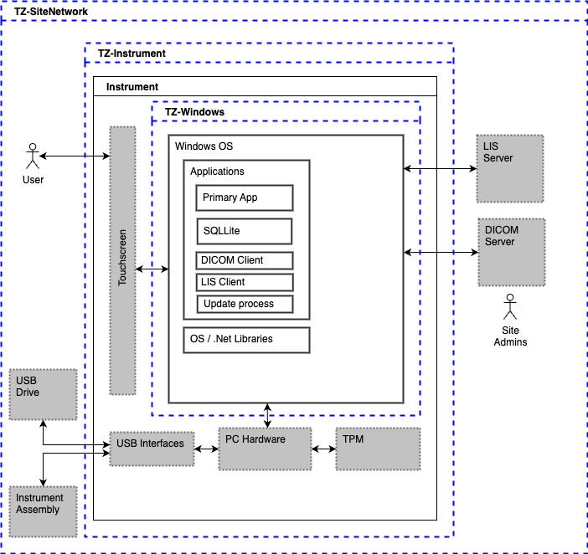

Security View
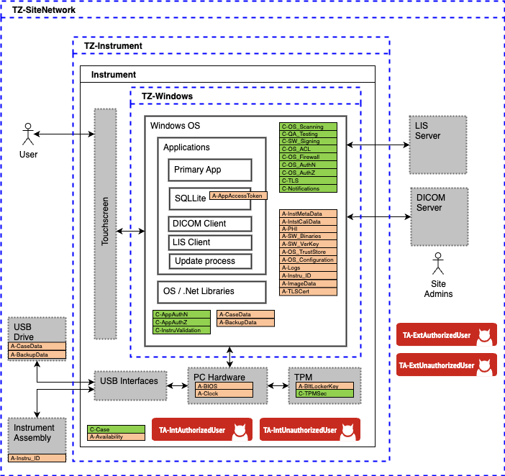
This section describes the MyCustomProduct from a security perspective. Among other elements, it includes assets (elements of value) and controls (mechanisms that protect the assets). To show how these elements relate to the system, Error! Reference source not found. overlays them over the system diagram already presented in Error! Reference source not found..
Figure 2: System Security View

Assets
Assets represent data, functionality, or a resource of the MyCustomProduct that, if affected (e.g., stolen, defaced, forged), would cause a negative effect to a stakeholder. A Threat Agent may be interested in targeting an asset, but assets may also be affected by accident (e.g., a reckless attacker could wipe a database with a wrong command) or as a first step towards targeting a different asset (e.g., cryptographic material or user credentials are not usually a target on their own, but attackers can target them to access the data they protect).
Note that as the MyCustomProduct is currently under development, the assets identified may be considered draft until system development activities are locked down for a production baseline.
The following assets were identified:
Asset Short Name | Name | Description
A-AppAccessToken | Application Access Token | User id and passwords for normal and service accounts users for the software application. Stored and accessed via the SQL Lite database (as per system requirements REQID-100, REQID-111, REQUID-112, and others).
A-Availability | System availability | Overall system availability. This asset is meant to capture the overall availability concerns and ensure their inclusion in
A-BackupData | Backup Data sets | Backup data written and read from a USB drive inserted into the system (as per system requirements REQID-10, REQID-11, REQUID-12, and others).
A-BIOS | BIOS | Embedded computer BIOS / UEFI settings.
A-BItLockerKey | BitLocker Key | The BitLocker key used for SSD encryption by the Windows installation. Held in the hardware TPM per system requirement REQID-2001.
A-Clock | System clock | The system hardware clock referenced by all timestamp creation routines and certificate and token validation routines. In any system where logs are collected or time-based tokens or certificates are used, a clock becomes an asset that must be protected.
A-Instru _ID | ID from instrument catheter | Timestamp and serial number written passed up from connected catheter instrument to verify existence of attachment (as per system requirements REQID-99, REQID-67, REQUID-32, and ICD-3.4.1).
A-Logs | Logs | System and software logs collected during operation.
A-MOREETCETC | More assets, etc, etc | All other assets would continue this table.

Controls
Controls protect assets from attacks. Most controls apply to particular stages of the information flow. Some protect the communication channels (e.g., TLS, firewalls), some the data storage (e.g., database encryption) and some the way in which the data is accessed and processed (e.g., data validation, access control).
Note that one control can protect several assets (e.g., the same TLS connection can protect different types of data) and no single control is enough to entirely protect an asset.
In the design of MyCustomProduct, the following controls were identified.
Control Short Name | Name | Description
C-AppAuthN | Application Authentication | Application authentication acted on via the application interface
C-AppAuthZ | Application Authorization | Authorization mechanism associated with service and normal user accounts.
C-Case | Case | The physical case that prevents access to the internal components.
C-IntruValidation | Catheter validation | Catheter functional validation and stored timestamp check performed on instrument assembly attached via USB (as per system requirements REQID-99, REQID-67, REQUID-32, and ICD-3.4.1).
C-DBAuthN | Database Authentication | Database access requires authentication
C-TPMSec | TPM Security | Use of the Trusted Platform Module (2.0) for secure cryptographic functions.
C-MOREETCETC | MORE CONTROLS | More controls from Threat Model Diagram would be listed here.

Trust Zones
Trust Zones represent the aggregations of common controls, effectively areas where a common set of security features exist, where these controls provide equivalent areas of protection to all components in the trust zone. Another way to view this is that in the relationships in a system. components within the same trust zone trust each other more than components in different zones because with-in that context the expectation of security is equivalent. Systems may also have trust zones within other trust zones, indicating that specific controls are modified in the embedded trust zone, or new controls are in place in addition to those outside the embedded trust zone. Particular concern should always be placed on communication channels that leave one trust zone and enter another.
Some trust zones represent areas of the system that are controlled by different actors (e.g., back end vs. mobile app). Others reflect a difference in the level of access or the degree to which the data or the users has been validated (e.g., DMZ vs. Intranet). In all these cases, the differences may be mapped back to the expectations of controls in place (or the lack of controls) based on context.
Components or actors outside all trust zones are entirely untrusted (e.g., arbitrary Internet users). This does not mean that they are malicious per se, but they could be. The system should treat any interaction with untrusted peers with utmost care. As a rule, the “Internet” is often listed as a trust zone, with the idea being that this trust zone has zero expected security controls in place for the environment or actors in the environment.
The following trust zones were identified for MyCustomProduct:
Name | Description
TZ-SiteNetwork | The is the trust zone the client device interacts with. This includes all local services provided by the local network.
TZ-Instrument | This is the trust zone of components of the system.
TZ-Windows | This zone represents the Windows OS software and associated security controls.

Threat Agents
Threat agents (TAs) are individuals, events, software, etc. whose actions may compromise the security of one or more assets.
When thinking of security, it is common to think of TAs as actors with malicious intent (such as a hacker or a disgruntled employee), but sometimes they may also be involuntary actors (such as a misconfigured web crawler or a database admin who deletes a database due to a typo).
Threat agents can thus be differentiated by their nature (human, system), their access level (staff, user, unauthorized), their skill level (novice, state-sponsored group) or their intent (malicious, accidental). For the sake of brevity, only the most realistic and relevant TAs are listed below:

Short Name | Name | Description
A-IntAuthorizedUser | Internal Authorized User | Authorized internal threat agents are legitimate system users or functions that have access to internal resources and components within the system.
A-IntUnauthorizedUser | Internal Unauthorized User | Unauthorized internal threat agents are users or endpoints that should not have access to components within the system assembly.
A-ExtAuthorizedUser | External Authorized User | Authorized external threat agents are legitimate external users or endpoints that have access to components within the MyCustomProduct assembly. This group includes the trusted personnel listed in the Software Cybersecurity Analysis document XXX-01 accessing the system per ICD-4.6.1.
A-ExtUnauthorizedUser | External Unauthorized User | Unauthorized external threat agents are external users or endpoints who should not have access to components within the MyCustomProduct assembly. This includes the untrusted actors listed in the Software Cybersecurity Analysis document XXX-01 (hospital visitors and patients).

Positive Baseline Security Findings
The following are positive findings Synopsys captured during the program review. Positive findings may be considered foundational security related features of the system and development process that this report is dependent on. If these findings are removed, the baseline security of the system will be changed, and subsequent technical issues may increase or change. The positive findings are:
- Use of BitLocker with TPM: This is a best practice with Windows OS based implementations for SSD data-at-rest security
- Hi-fidelity quality test process: The Quality Management process in place reduces the number of development faults that may be leveraged by attackers.
- Use of scanning tools for development pipeline: the use of source-code scanning tool (identified as Synk) in the development process is a best practice.

Technical Risks
Technical risks result from design weaknesses, such as vulnerabilities in the technology stack, insufficient validations, the use of insecure protocols or the misconfiguration of tools. To understand how the severity of risks is rated, see Risk Severity.
This section contains the technical risks identified for MyCustomProduct, sorted by severity. Table 1 provides an overview of the ratings and, when applicable, the CWE (Common Weakness Enumeration) and business risks associated.

Table 1: Technical Risks
Technical Risk |  | Severity
No Critical Risks
High Risks
LIS Connectivity |  | High
Data Integrity Weakness |  | High
DB Encryption |  | High
Privilege Architecture |  | High
Hardening Process |  | High
Password Hashing |  | High
Weak Security Logging |  | High
Medium Risks
Startup Validation |  | Medium
DLL Signing |  | Medium
Low Risks
No Cryptographic Validation |  | Low
DICOM Preamble Vulnerability |  | Low
Minimal Risks
No Audit Role |  | Minimal
No Update Role |  | Minimal

Critical Risks
No critical risks. Critical risks for attacks and weaknesses are generally defined as systematic risks that impact multiple assets across organizational boundaries.

High Risks

LIS Connectivity
ID  R1 | LIS & DICOM Connectivity  LIS & DICOM connections allowed with no TLS | Likelihood  High | Impact  High | Severity  High
CWE
CWE-319
Description
LIS connections are allowed without TLS.
Likelihood
High
High. This is a known issue and leads to multiple channel security vulnerabilities.
Impact
High
High. At any given time, LIS connection will be limited to one patient dataset (as opposed to a connection that transmits data for multiple patients at once).
Mitigation
This is a known issues with legacy LIS and DICOM installations and reflects an issue with organizations not adapting guidance from DICOM supplement 230. In most cases this is a carried risk due to customer requirements for operation. While this will be a carried risk due to customer requirements, the risk should be understood, documented, and tracked. Mitigations to the risk include....

Data Integrity Weakness
ID  R2 | Data Integrity Weakness  Weak data integrity plan | Likelihood  High | Impact  High | Severity  High
CWE
CWE-353
Description
Files (data, configuration, etc.) currently rely on Windows OS permissions for protection of integrity or weak (SHA-256) integrity checks.
Likelihood
High
Any compromise that leads to access of the Windows OS allows leveraging this weakness.
Impact
High
Varies according to the specific file modified by an attacker, with a max impact of high.
Mitigation
Consider the addition of integrity check mechanisms, including cryptographic hashes and message-authentication-code (MAC) values for all assets that are critical to system operation. These include not only configuration files, but also the timestamp written to ... Synopsys also noted that software requirement REQUID-999 references SHA-256 hashes for configuration files, but the requirement (A) has no matching requirements for how the hashes are to be handled, (B) relies on a SHA algorithm (SHA-256) that is headed for sunset, and (C) limits the scope to “configuration files”. The use of integrity checks should target configuration files, database values, and procedure specific information that is important. For keyed MAC values and digital signatures, the TPM may be leveraged for the operation. For larger aggregations of files that are set at production and never modified operationally, consider a manifest of SHA3 hash values with the manifest then signed at production. Also consider ….

DB Encryption
ID  R3 | DB Encryption  No DB level encryption used | Likelihood  H | Impact  H | Severity  High
CWE
CWE-311
Description
Database stores are protected via data-at-rest (DAR) encryption (BitLocker), but no operational encryption is used (as understood by the current allocation and implementation of REQUID-908). DAR encryption protects data at the volume level if the media is removed, but not operationally when the system is running. If an attacker gains access to the system OS, data may be exposed, either by accessing the database itself, or the underlying database files. While database credentials provide some level of protection, these access tokens to do provide a full defense-in-depth strategy.
Likelihood
High
Any compromise to the base OS may lead to a compromise of the database.
Impact
Varies
Varies according to the specific database field / table exposed and amount of data exposed.
Mitigation
Consider table, row, or column-based encryption (as appropriate to the schema). Encryption keys would be managed by the application at the database access layer. Note that there is still the risk of key exposure and data decryption, but...

Privilege Architecture
ID  R4 | Privilege Architecture  Weak privilege architecture | Likelihood  H | Impact  Varies | Severity  High
CWE
CWE-269
Description
System takes a monolithic approach to the primary application architecture with all application functions running as a specific system UID. In addition, certain functions are provided by privileged system services. This flat privilege architecture provides limited defense in depth of across functional elements in the event of a compromise or functional failure.
Likelihood
High
Multiple interfaces are exposed.
Impact
Varies
Varies based on the actual compromise.
Mitigation
Consider a finer grained approach to the architecture that highlights functions with exposed interfaces and implements privileges limited to the specific resource needs of the functional element. Synopsys understands that there is consideration for least privilege (REQUID-4892), but they current requirements are broad and not specific enough to drive a privilege analysis at the architecture level. Instead of requesting an application run with “least privilege”, an analysis should be conducted to first understand what privilege levels are required and then allocate appropriate requirements to ensure each functional element is scoped to a specific privilege profile.
The current approach is shown in an example architecture presented in Figure 3 below…. … may be considered more trusted than the USB subsystem as the touchscreen is shipped with the system, is of a very specific model and function, and is not designed to be detached/replaced/modified by the end user. The USB interface for a USB drive is dealing with an unknown device provided by the customer and a device that could change during operation. All external network connections should be considered untrusted until the system can implement controls on those connections to establish a level of trust for the channel. This privilege model is often found in software applications regardless of the underlying operating system as the model provides for rapid development and fielding of new functions with minimal effort in understanding or limiting the privileges of new functions.
As an alternative, consider Figure 4 below.

Figure 3 : Current Privilege Model
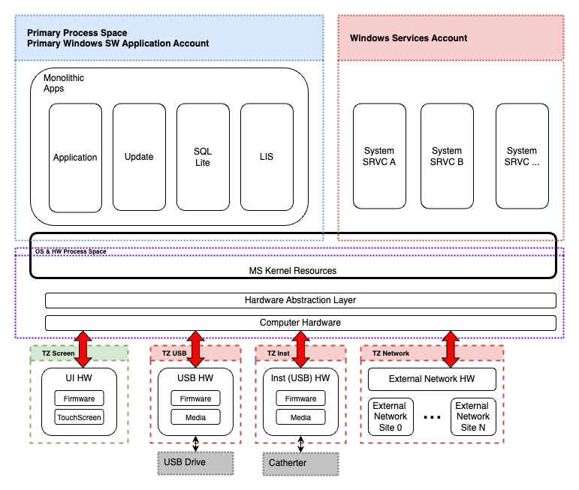
In Figure 4 we have the same layers, but the top layer is more defined and includes multiple trust zones….
The use of additional privilege tailored process spaces could also be considered for the functional differences between the application’s normal and service accounts. The current delineation between the two different accounts ….
An additional consideration in the privilege analysis is the difference between local and remote users and functions. For a medical device, local users, those physically present with the device and the patient, already have an established level of trust based on the physical security controls that allowed that local user access to the device and patient in the first place. A reasonable expectation .
In consideration of this, the “Data Handler Process Space” is an example of the use of internal proxy functions for privilege separation and risk avoidance. A data handler is a function that takes data from one interface, verifies and perhaps formats the data, and hand that data off to another interface. This type of architecture pattern already exists within the architecture, as demonstrated by software requirement REQUID-503 for the database proxy layer and may be...
The use of the data handlers is shown in Figure 5. This figure highlights the primary...
Figure 4 also highlights the update process...
Figure 4 : Full Privilege Separation Model
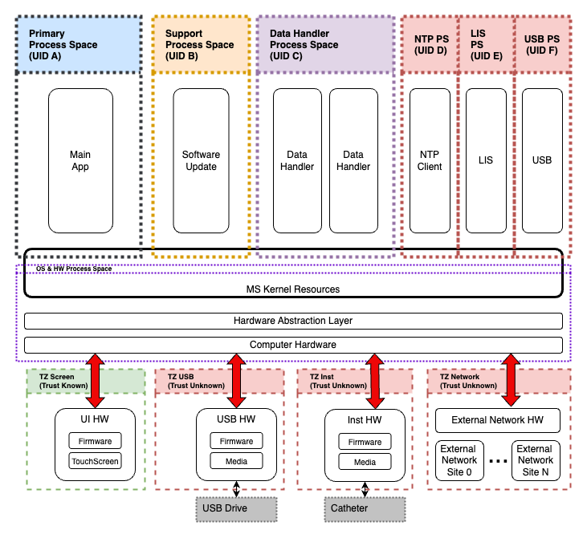

Figure 5: Data Handler Examples
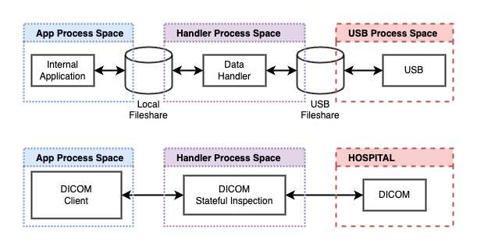

Hardening Process
ID  R5 | Hardening Process  No clear OS hardening process | Likelihood  H | Impact  Varies | Severity  High
CWE
CWE-16, CWE-693
Description
While specific OS hardening features are documented in the software requirements, there is currently no overall OS hardening process defined.
Likelihood
High
This covers multiple known issues with Windows configuration with known attack concerns
Impact
Varies
Impact varies according to the specific concern.
Mitigation
Consider putting in place a specific OS hardening process based on a documented standard. Recommendations for starting the process includes the CIS Benchmarks and DISA STIGs. In all cases the hardening process will need to be tailored for an embedded medical system. The tailoring should ensure the hardening process meets the final operational requirements and accepted risk profile for the system. Note that once the selected standard is tailored, the hardening process may be automated for consistency and speed.

Password Hashing
ID  R6 | Password Hashing  Use of SHA-265 for password hashing | Likelihood  High | Impact  High | Severity  High
CWE
CWE-916
Description
SHA-256 is insufficient as a password hashing algorithm (REQUID-261). Modern hashing mechanisms related to crypto-currency mining have produced machines that can create large volumes of hash dictionaries. This is in part due to the design nature of the SHA2 functions – they were intended to be calculated efficiently on the resources available at the time of their design. Algorithms that require additional work / time allocation should be used.
Likelihood
Medium
Requires database access.
Impact
High
User passwords exposed.
Mitigation
Consider using PBKDF2 or Argon-2 for hashing. Note that while Argon2id is an OWASP and IETF recommended algorithm, it is not currently part of the NIST standards. If NIST adherence is required, consider PBKDF2. Note that all cryptographic algorithms should be verified for fidelity prior to operational uses. For PBKDF2 consider the NIST Test Vector suite for verification of functionality, for Argon2 use vectors published in RFC9106.

Weak Security Logging
ID  R7 | Weak Security Logging  No consolidated security audit process defined across software and OS. | Likelihood  H | Impact  Varies | Severity  High
CWE
CWE-16, CWE-693
Description
The security audit process consists of monitoring a system for possible security events and responding to those events, as well as retaining records of those events for later forensic analysis. For cyber security systems, the response and retention is as important as the detection. In 2016 an OWASP review determined that identifying a datacenter breach took on average 191 days. Put another way, on average an attacker had the ability to access a system for 6 months before any action was taken against them. In the interview process Synopsys noted that the MyCustomProduct has multiple logging mechanisms and log streams, but these are independent and are not focused on supporting a security specific view. There is no process or system level efforts to review them across these individual pipelines for security specific events. Even in cases where the same personnel may monitor different logging systems (for example Windows OS security events and software log events), no security specific effort is made to review those logs in concert for to tie similar security specific events together highlighting a possible attack.
Likelihood
High
Likelihood varies according to the subsystem, but no greater than a high as the lack of security specific monitoring means an attack could be missed.
Impact
Varies
Impact is high as consolidated audit is needed for effective incident response to ensure that an attack is addressed as soon as possible.
Mitigation
Implement a defined security event logging and audit process so that software and operating events, including those related to the PIM, are covered. Ensure that for software logging, security relevant events are tagged to allow quick collection and highlighting of these events. Examples of the types of events that should be captured across the system components include (list taken from OWASP best practices):
Implementation events:
[Example List]…
The list above is of course an example, but provides…
… Once a base set of events and monitoring processes are in place, pick a couple example attacks and determine how quickly the attack might be detected. This exercise will aid in determining retention periods for the records that span the attack (for forensic analysis) and the effectiveness of the plan. Additional considerations may be obtained be reviewing NIST guidance on forensics, as the nominal goal of any audit and records keeping system should be to provide robust forensics support.
Based on program needs, ….

Medium Risks

Startup Validation
ID  R8 | Startup Validation  Weak startup validation | Likelihood  Medium | Impact  Varies | Severity  Medium
CWE
CWE-501, CWE-1357
Description
System starts up and immediately assumes that all components, internal and external, are as shipped from production manufacturing and ready for operation. No explicit trust establishment via component validation is executed, outside of a summary check of instrument data.
Likelihood
Medium
Components may be swapped impacting system integrity or availability.
Impact
Varies
Varies depending on the specific component and function.
Mitigation
Consider creating a more POST process (REQUID-201) across components at startup. The security focused POST would include tests for…
Based on the level of functionality demonstrated by that known state, the system may (A) proceed with full...
A broader approach to monitoring and reacting to system trust and validation issues (also known as system attestation) is presented in Table 2. Here, …. the system responds with a reasonable state change or system level event.

Table 2: Generic Attestation Response Flow
Response Severity | System Response | Trigger(s) to Execute Response
LOW | Log application or system error. | - Response 1
MEDIUM | System reboots. Tamper reboot counter incremented by one. | - Response 2  - Multiple response 1 events
HIGH | Boot key for system’s encrypt disk is deleted, system forced to shut down. Renders system unusable and forces device to be returned for inspection. | - Device experiences 10 medium tamper events that force a reboot without a reset on the tamper reboot counter.  - Detection of unapproved remote user.
Another possible addition to the startup validation process would be to encrypt specific … based on keys splits. Key splits are created by …
By managing the different ways the key splits are created and stored the MyCustomProduct ensures that the components are configured as intended. Key splits may be as simple as …
An example is provided in Figure 6. Here four key splits...
Figure 6: Key Split Example
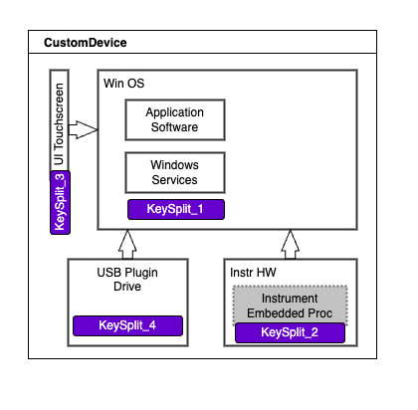

DLL Signing
ID  R9 | DLL Signing  Third party DLLs are not signed. | Likelihood  Medium | Impact  Varies | Severity  Medium
CWE
CWE-345: Insufficient Verification of Data Authenticity
Description
All software running on the system should be signed and have that signature verified at runtime.
Likelihood
Medium
Malicious software replacement is a technically complicated task.
Impact
Varies
Varies according to the specific attack vector.
Mitigation
Ensure that all loaded software...

Open USB Access
ID  R10 | Open USB Access  No restrictions for USB devices | Likelihood  Medium | Impact  Varies | Severity  Medium
CWE
CWE-284
Description
Any USB device may be plugged in for use as a data source.
Likelihood
Medium
Devices are easy to plug in.
Impact
Varies
Impact varies based on specific operations
Mitigation
Restrict what devices are allowed to connect to the system. This may be accomplished via Microsoft Intune or ...

Open USB file enumeration
ID  R11 | Open USB file enumeration  No file or volume restrictions for USB file systems. | Likelihood  Medium | Impact  Varies | Severity  Medium
CWE
CWE-345: Insufficient Verification of Data Authenticity

Description
Files are read off of inserted USB media with limited verification (filename based) prior to data access. This is an open enumeration in that no defined list of specific data items is allowed. Instead a closed enumeration should be…
Likelihood
Medium
The ability to load or craft malicious payloads into data files has a long history in information security and is a known attack pattern.
Impact
Varies
Varies based on specific attack vector.
Mitigation
The design team should consider an enumerated list of accepted files for reading and...

Software Signing Key Exposure
ID  R12 | Software Signing  Private key not on secure channels | Likelihood  Medium | Impact  Medium | Severity  Medium
CWE
N/A

Description
While still on a restricted subnet, the software signing process allows the key to be exposed.
Likelihood
Medium
Corporate network.
Impact
Medium
Multiple keys used, so impact limited.
Mitigation
Consider using.... per the diagram below, Figure 7.
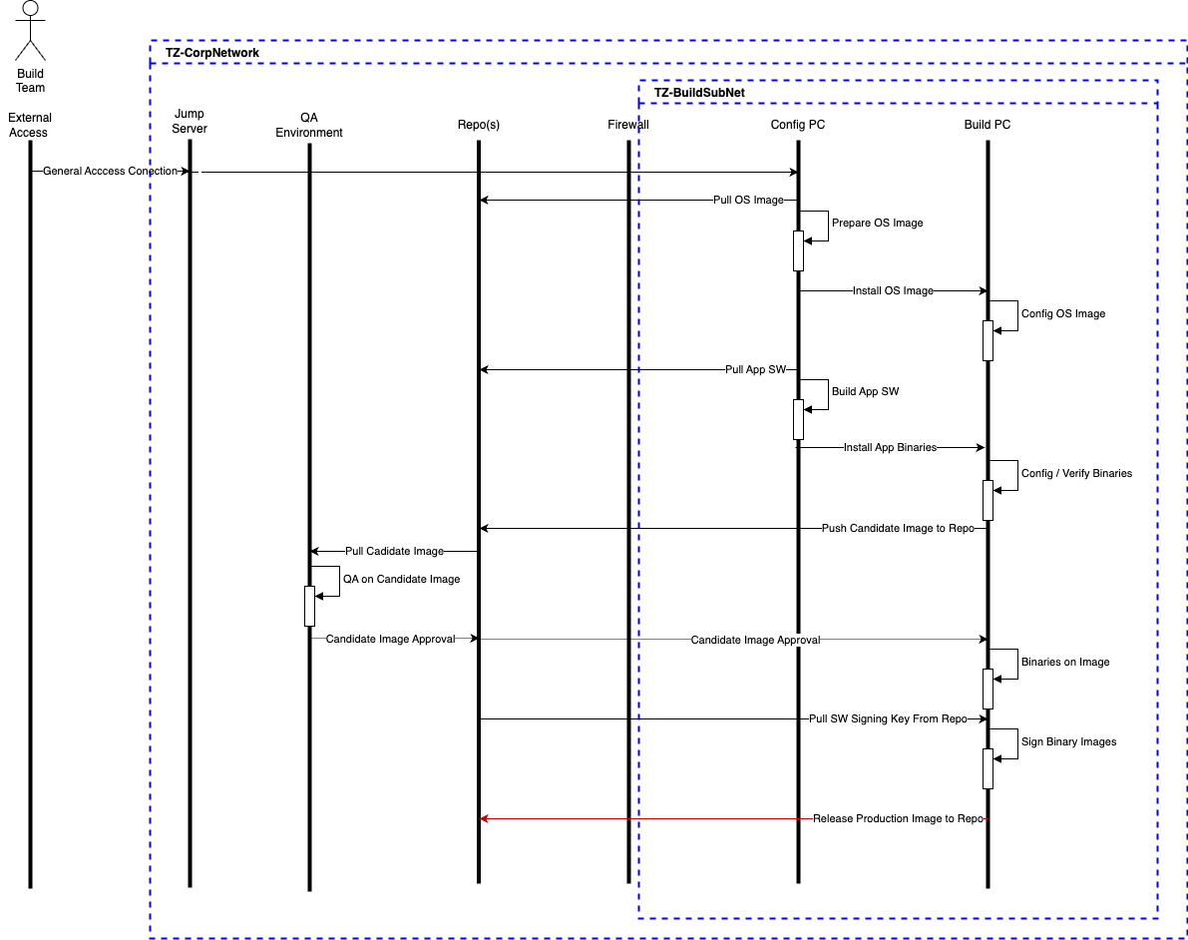
Figure 7 : Software Build Process

Low Risks

JWT validation
ID  R13 | JWT Validation  JWT validation for Backend App | Likelihood  Minimal | Impact  High | Severity  Low
CWE
CWE-754: Improper Check for Unusual or Exceptional Conditions

Description
Multiple security controls … form of validation.
Likelihood
Minimal
Requires a technical understanding of system interactions and privileged access to the system.
Impact
High
Impact dependent on the way … possible software failures.
Mitigation
Consider... These would include: …. Per Figure 8.
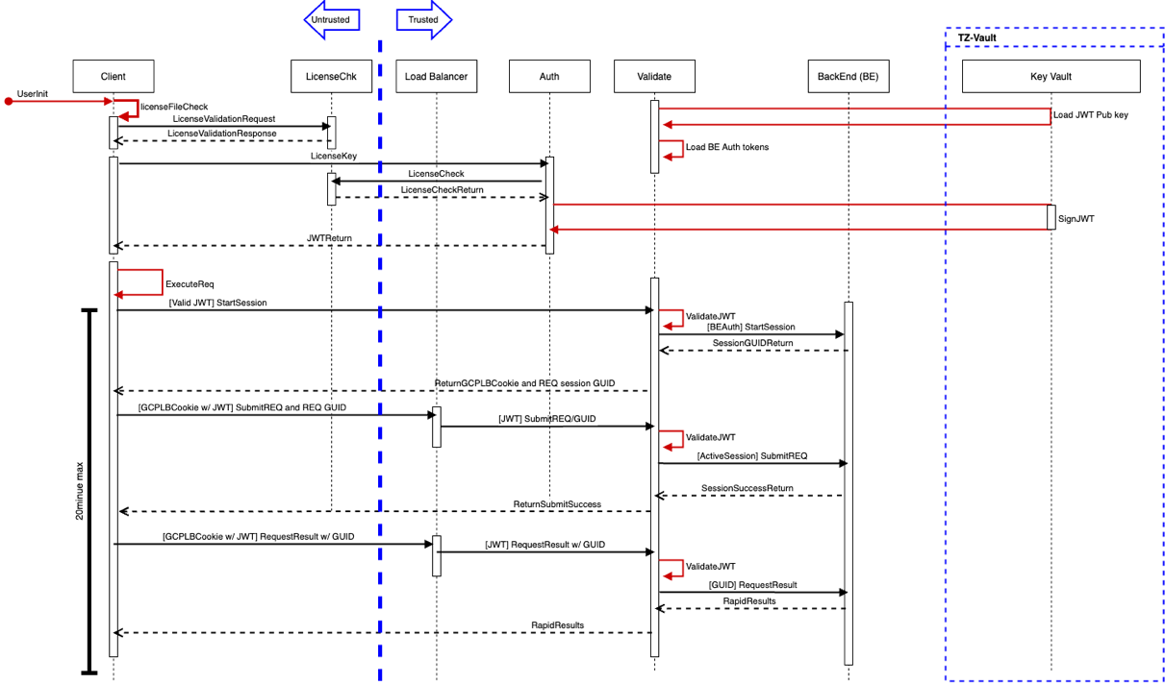
Figure 8 : Request Execution

No Cryptographic Validation
ID  R14 | No cryptographic validation  System does not validate cryptographic libraries after installation. | Likelihood  Minimal | Impact  High | Severity  Low
CWE
CWE-754: Improper Check for Unusual or Exceptional Conditions
Description
No specific validation checks in place for cryptographic primitives used for system operation.
Likelihood
Minimal
Technically difficult attack
Impact
High
A compromised or incorrectly configured cryptographic primitive would impact overall system security.
Mitigation
For libraries that allow the option, enable FIP-140 mode as this will enforce startup system checks across all features available. For libraries without a FIPS-140 mode, or if the execution of validation routines across all elements is too time consuming, consider the use of NIST test vectors to ensure the proper operation of cryptographic primitives used (such as AES, EC, etc.)...

DICOM Preamble Vulnerability
ID  R15 | DICOM Preamble Vulnerability  DICOM Preamble Vulnerability not addressed | Likelihood  Low | Impact  High | Severity  Low
CWE
N/A
Description
No requirements addressing DICOM Preamble Vulnerability
Likelihood
Low
Technically difficult attack.
Impact
High
May allow for corruption of operational software.
Mitigation
Address impact of DICOM preamble vulnerability has on system in cyber security documentation and any mitigations in place.

Minimal Risks

No Audit Role
ID  R16 | No Audit Role  No defined audit role for system | Likelihood  Minimal | Impact  Minimal | Severity  Minimal
CWE
CWE-272: Least Privilege Violation
Description
There is no audit specific user role defined, meaning that privileged or maintenance level account access must be used to collect log information.
Likelihood
Minimal
Only useful for covering up existing attacks.
Impact
Minimal
Only useful for covering up existing attacks.
Mitigation
A best security best practice is to create a separate role for the audit function that does not need the elevated privileges of an administrative role, and does not allow functional execution of maintenance operations, as neither of these are required to collect log information.

No Update Role
ID  R17 | No Update Role  No defined update role | Likelihood  Minimal | Impact  Minimal | Severity  Minimal
CWE
CWE-272: Least Privilege Violation
Description
Current design has update process rolled into service type account and leveraging Windows update process.
Likelihood
Minimal
Service account is audited.
Impact
Minimal
A failed or compromised update would be detected and rolled back.
Mitigation
Consider forcing the update operation to require…
.

Process Risks
While the assessment focused on the technical risks identified in the previous chapter, additional risks were identified that are not (exclusively) of technical origin. Instead, they are related with the processes supporting the system.
Process risks roughly fit into two categories: either they can be abused to cause damage to the MyCustomProduct (e.g., a password-recovery process via phone that fails to authenticate the user sufficiently) or by failing to support the security of the system (e.g., insufficient security testing).
Unlike technical risks, process risks are not rated. Nevertheless, we believe it is important for Acme Inc. to be aware of these risks.

No clear risk management process for software review
Current system uses DAST/SAST software in development pipeline, but the is currently no clear feedback mechanism to software groups or tracking of issues for parametric considerations. Consider adding security specific callouts to software code review activities, and use...

No clear cryptographic key management plan defined.
While multiple cryptographic keys are in use across the system, no key domains are defined. Key domains scope the use of specific keys. Keys may unique per system, per target customer, or per region...
One way to initiate this analysis process is to create a key management plan. In addition to aiding in planning, maintaining a key management plan (KMP) should be considered…
Consider the example provided in Table 3. This is the start of a systematic documentation process…
.
Table 3: Example KMP Table
Key Name  (Short Name & Long Name) | Target Alg & Size | Used with ? and Expected # Required | How Generated? | Controls in place for protection of Key Material | Required Lifespan | POCs
DB-Symmetric-Key-𝛼  Database Symmetric Key | AES-128-CTR | Example | Example | Example | Example | Example
PASSWD-BitLocker-DAR-Key-n  BitLocker Password Data-At-Rest Key n | AES-128 | Protect Embedded-BitLocker-DAR-Key-1 (DAR=Data-At-Rest) for manufacturing workstation.  Example. | Example | TPM | Life of hard drive protected by Embedded-DAR-Symmetric-Key- 𝛼 | Example
SWSignKey  Private-Software-Signing-Key | ECDSA | Private key used to sign software before release. Paired with SWVerKey. | HW/SW | Production Azure Vault | Life of product unless exposed. | Example
SWVerKey  Public-Software-Verification-Key | ECDSA | Public key paired with SWSignKey. Used to verify software signature. | HW/SW | OS Trust Store | Life of product unless exposed. | Example
DICOMTLSCert | TLS_CHACHA20_POLY1305_SHA256 | Used for DICOM TLS Comms | HW/SW | OS Trust Store | 5 years. | Example

Consideration should also be given to ...

Quality process missing security risk register input
The current quality process is good, but there are no clear feedback mechanisms to capture security risk in a traceable risk register...
Also consider adding a full Security Test and Evaluation (STE) exercise as part of the Test Readiness Review (TRR) event…

No consistent secure development approach
Synopsys noted that multiple secure development tools and processes are in place, but no consistent approach across all phases what present. In interviews with development staff Synopsys noted that no clear update process..
Moving forward, Synopsys recommends reviewing development practice against secure development best practices to better align processes consistently across projects. The goal for handling security defects, as is the case for all software defects, is to identify and address them as early as possible in the development process.
Nominally, Synopsys recommends the following to address secure development issues:
…
Additionally, Synopsys noted substantial third party involvement..
Cybersecurity engineering efforts should be involved with all elements of a supply chain risk management approach, as without security engineering input, supply chain risk management is often reduced to fraud and force majeure issues. For perspective, and as a start to approaching and scoping these issues, consider these tailored checklists, based on the DoD Trusted Systems and Network (TSN) Analysis document. These checklists have been tailored to commercial needs and are meant to scope and understand an effort, and are not meant be used as requirements):
Supply Chain Vulnerabilities Checklist
[Custom Checklist]…
Software Development Vulnerabilities
When creating a Statement of Work (SOW) for contracted software development services:
[Custom Checklist…]
Again, these checklists are meant to start the discussion and aid in scoping what specific SCRM needs are required for a project. Each should be considered for tailoring to the specific vendor and project SOW. Additional guidance may be found by reviewing the NIST 800-53 SA-12 Supply Chain Protection Family and NIST 800-161, “Supply Chain Risk Management Practices” documentation. The NIST Assessment Case for the SA-12 family may also be reviewed to assist in creating a SCRM process.

- The Synopsys Approach
A System Architecture Risk Analysis at Synopsys usually follows 6 stages:
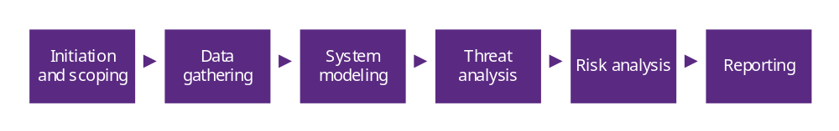
This appendix briefly describes each of them.

Initiation and Scoping
Synopsys Threat Modeling portfolio encompasses several services.
When a customer comes to Synopsys in search for a Threat Model, Synopsys and the customer will discuss requirements, business objectives and the overall context. Synopsys will help the customer identify the most suitable service and together they will set scoping parameters and boundaries for which components should be covered. The conclusion of this phase results in understanding of overall effort and expected delivery timeline for the assessment.
This phase usually takes place prior to issuing an offering.

Data Gathering
Once the scope has been defined, Synopsys compiles information about the system. “Information” in this context includes design documents, stakeholders’ goals, de-facto practices, specifications, end-user documentation, and others.
Interviews with key contacts identified by the customer are the main source of information, followed by files and diagrams shared in their wake. In sum, consultants will analyze anything that helps understand how the system works, what information in it is valuable, how different actors interact with each other, which security controls are in place or how the different components could be abused.
Worth noting: The rest of the analysis will rely exclusively on the information collected in this phase. Any claims about the threat landscape can only be accurate as the information provided.

System Modeling
In this phase, Synopsys organizes the data gathered in the form of a succinct product description. Usually, this description will be accompanied by a system diagram (complex systems may require several) that focus on three aspects: the depiction of all components relevant to the system, the identification of the scope and the communication between components, including protocols.
Once complete, Synopsys creates an annotated version of the diagram focused on the security components. It overlays the diagram with assets, controls, threat agents and trust zones. These components constitute the basis for the identification of threats during the next stage.

Threat Analysis
The objective of the threat analysis is to identify the threats to the system. The analysis will explore data assets, data flows and existing controls to identify realistic threats to the system. By its nature, the analysis cannot be exhaustive, but if approached systematically the results can be quite comprehensive.
Synopsys uses one of two artifacts to enumerate threats: traceability matrices or attack trees.

Risk Analysis
After identifying threats at technical and process level, Synopsys will rate the severity of the risks associated (see Appendix B: Risk Severity). There will be other factors influencing the rating, such as the business goals and regulatory constraints that may apply.
Synopsys will also identify remediation strategies that can help the customer mitigate the risks identified. (Note: These are not requirements. The decision whether to implement or not a given control is up to the customer.)

Reporting
The main deliverable of the analysis is a PDF report containing all information used during the analysis (e.g., architecture diagrams, component description), contextual information (e.g., scope, assumptions), security artifacts (e.g., assets, controls) and the identified risks.

- Risk Severity
Once the technical risks have been identified, they are prioritized based on their severity, determined as a function of their likelihood and their impact. The possible values for likelihood, impact and severity are based on the NIST 800-30 standard.

Likelihood
The likelihood of a risk can take one of the following values:
Highly Likely: An attacker is almost certain to initiate the threat event.
Likely: The threat may materialize. Factors like externally exposed interfaces or missing technical controls make it particularly feasible or attractive.
Somewhat Likely: There are some obstacles in the way (e.g. it needs knowledge of a rare technology, reverse engineering or internal knowledge), but the event can happen.
Unlikely: The threat requires significant malicious effort. It requires, for example, valid credentials, significant time, resources, equipment, or a specialized skillset.
Highly Unlikely: The threat remains technically possible, but it requires an extremely motivated and skilled attacker (e.g. a well-funded security research team).

Impact
The impact of a risk describes how the different stakeholders will be affected if the risk materializes. In cases where the expected impact may vary (e.g. because it depends on the reaction of the customers), the worst case will be assumed. Impact may take the following values:
Critical: The issue causes multiple severe or catastrophic effects on organizational operations, organizational assets or other organizations.
High: Exploitation produces severe degradation in mission capability to the point that the organization is not able to perform primary functions or results in damage to organizational assets.
Medium: Threat events trigger degradation in mission capability to an extent the application can perform its primary functions, but their effectiveness is reduced and there may be damage to organizational assets.
Low: Successful exploitation has limited degradation in mission capability; the organization is able to perform its primary functions, but their effectiveness is noticeably reduced and may result in minor damage to organizational assets.
Minimal: The threat could have a negligible adverse effect on organizational operations or organizational assets.

Risk
The severity of a risk combines the likelihood and impact ratings as described Table 4.
Table 4: Risk Level Matrix
Likelihood | Risk
Highly Likely | Minimal | Low | Medium | High | Critical
Likely | Minimal | Low | Medium | High | Critical
Somewhat Likely | Minimal | Low | Medium | Medium | High
Unlikely | Minimal | Low | Low | Low | Medium
Highly Unlikely | Minimal | Minimal | Minimal | Low | Low
Impact | Minimal | Low | Medium | High | Critical

Risk severity can ratings help guide the mitigation process, for example by determining the time frame for mitigation or deciding whether to accept the risk instead of mitigation.
A mitigation strategy based on risk severity could look as follows:
Critical: Address immediately or before system go-live
High: Prioritize mitigation or address before system go-live.
Medium: Document mitigation plan or generate backlog request for systems in development.
Low: Accept risk or remediate risk. Document mitigation plan.
Minimal: Accept risk or remediate risk. Document mitigation plan.

- Interview List
The Synopsys Team would like to thank the following members from the MyCustomProduct team for sharing their knowledge about the project through interviews and email exchanges, as well as for providing supporting documentation when needed:
- Foghorn Leghorn
- Lola Bunny
- Daffy Duck
- Elmer Fudd
- Porky Pig

- Change Log

Author(s) | Date | Version | Description
Bugs Bunny | 2024-05-31 | 1.0 | First draft

The Synopsys Difference
Synopsys helps development teams build secure, high-quality software, minimizing risks while maximizing speed and productivity. Synopsys, a recognized leader in static analysis, software composition analysis, and application security testing, is uniquely positioned to apply best practices across proprietary code, open source, and the runtime environment. With a combination of industry-leading tools, services, and expertise, only Synopsys helps organizations maximize security and quality in DevSecOps and throughout the software development life cycle.
For more information, go to www.synopsys.com/software.

The Synopsys Difference
Synopsys helps development teams build secure, high-quality software, minimizing risks while maximizing speed and productivity. Synopsys, a recognized leader in static analysis, software composition analysis, and application security testing, is uniquely positioned to apply best practices across proprietary code, open source, and the runtime environment. With a combination of industry-leading tools, services, and expertise, only Synopsys helps organizations maximize security and quality in DevSecOps and throughout the software development life cycle.
For more information, go to www.synopsys.com/software.

See: https://www.dicomstandard.org/News-dir/ftsup/docs/sups/sup230.pdf
See: https://www.cisecurity.org/benchmark/microsoft_windows_desktop
See: https://www.stigviewer.com/stig/windows_10/
See: https://www.cisecurity.org/insights/blog/how-to-automate-the-process-of-implementing-secure-configurations https://public.cyber.mil/stigs/supplemental-automation-content/ https://www.puppet.com/blog/disa-stigs (example app)
See: https://cheatsheetseries.owasp.org/cheatsheets/Password_Storage_Cheat_Sheet.html#argon2id
See: https://tools.ietf.org/id/draft-whited-kitten-password-storage-02.html
See: https://www.rfc-editor.org/rfc/rfc9106.html
See: https://owasp.org/www-project-top-ten/2017/A10_2017-Insufficient_Logging%2526Monitoring
See: https://cheatsheetseries.owasp.org/cheatsheets/Logging_Cheat_Sheet.html
See: https://nvlpubs.nist.gov/nistpubs/Legacy/SP/nistspecialpublication800-86.pdf
See: https://learn.microsoft.com/en-us/mem/intune/configuration/administrative-templates-restrict-usb
See: https://csrc.nist.gov/projects/cryptographic-algorithm-validation-program
See: https://www.dicomstandard.org/docs/librariesprovider2/dicomdocuments/wp-cotent/uploads/2019/05/faq-dicom-128-byte-preamble-posted1-1.pdf?sfvrsn=f4f75455_2
See: https://safecode.org/category/resource-secure-development-practices/
See: https://rt.cto.mil/wp-content/uploads/2019/06/Trusted-Systems-and-Networks-TSN-Analysis.pdf
See: https://nvd.nist.gov/800-53/Rev4/control/SA-12
See: https://nvlpubs.nist.gov/nistpubs/SpecialPublications/NIST.SP.800-161.pdf
See: https://csrc.nist.gov/projects/risk-management/security-assessment/assessment-cases-download-page

